**BANKING SYSTEM APPLICATION**

**OUTPUT SCREENSHOTS**

**BANK SCREENSHORTS**

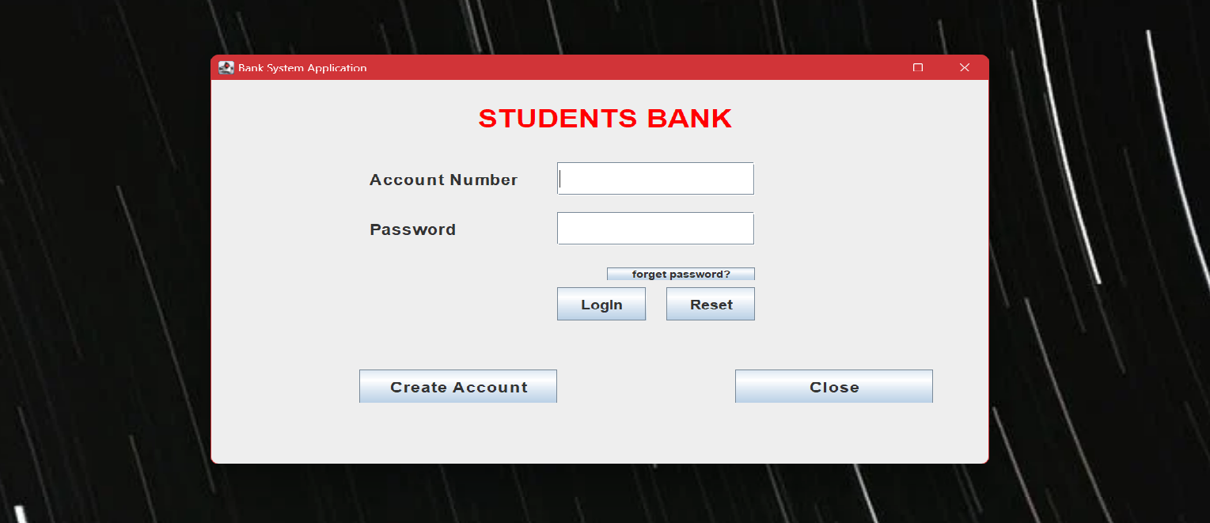

Fig.1 Bank Login Page

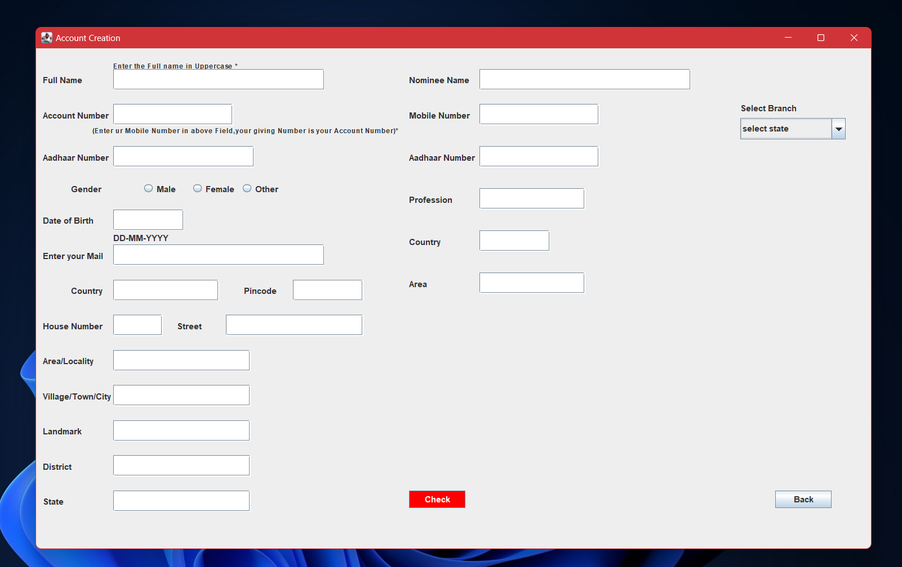

Fig.2 Bank Account Creation Page

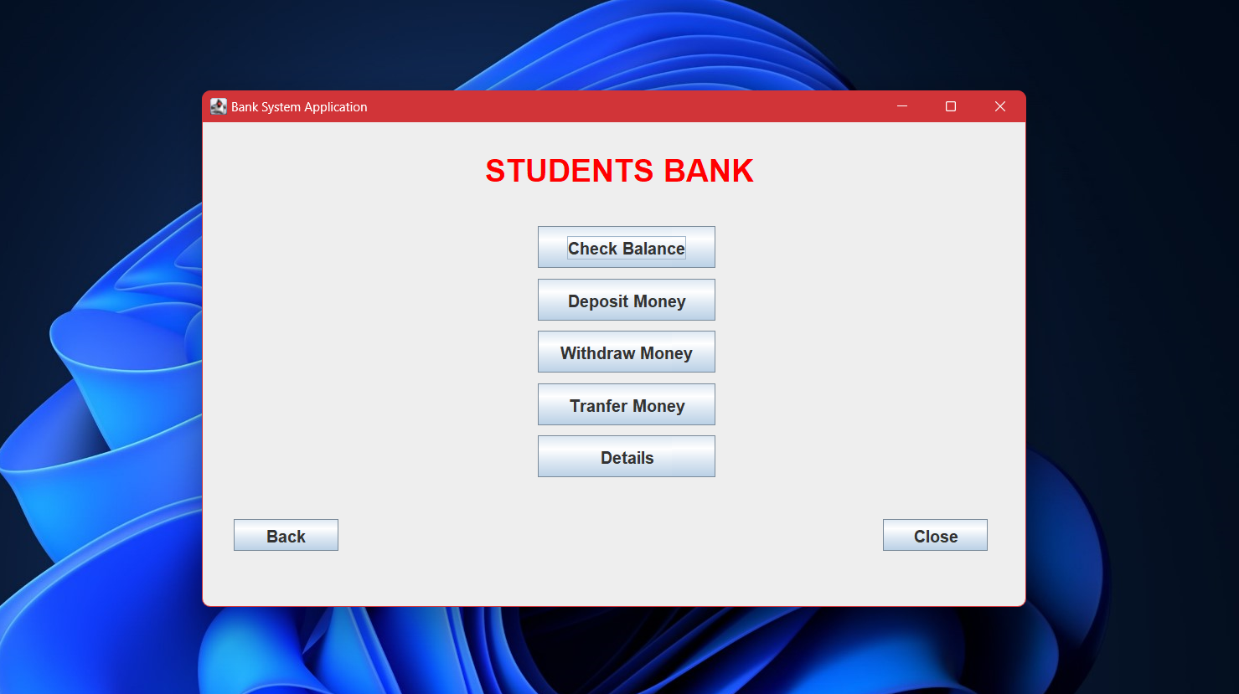

Fig.3 Bank Options Page

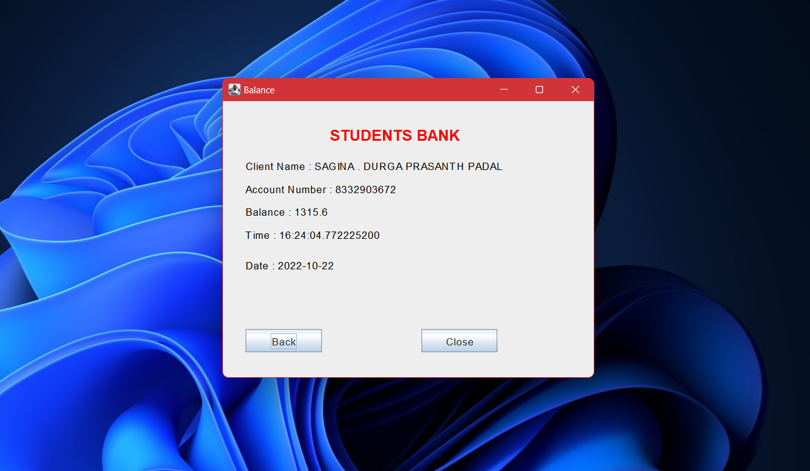

Fig.4 Balance Enquiry Page

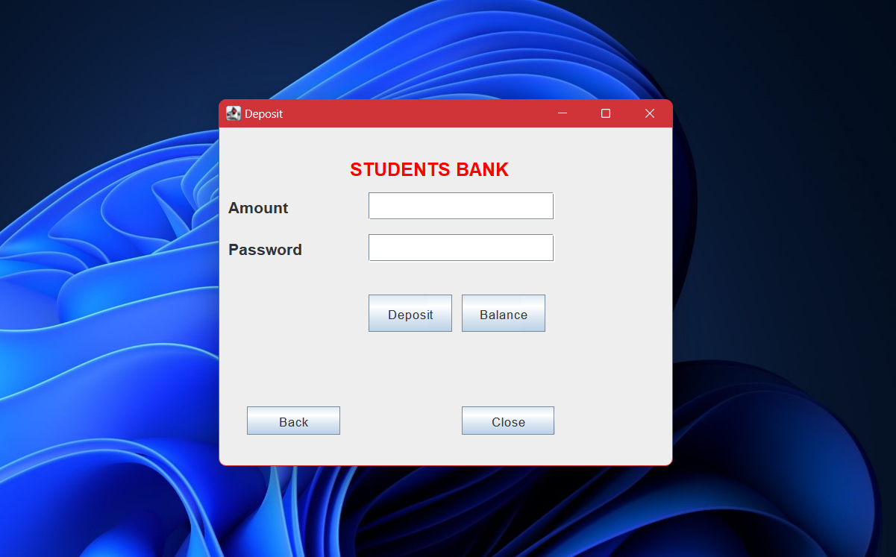

Fig.5 Money Deposit Page

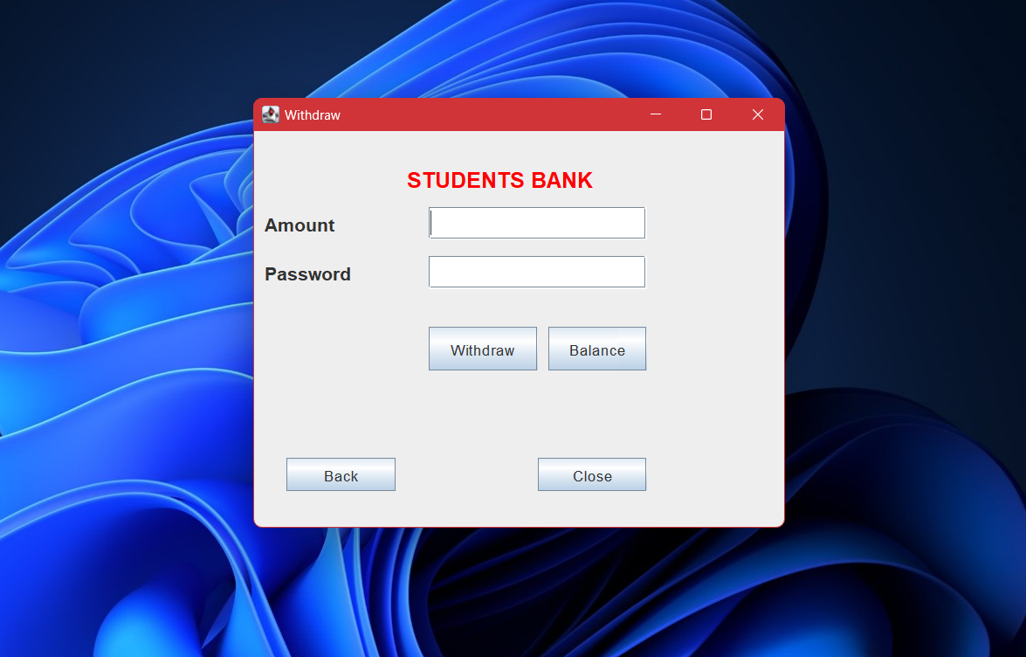

Fig.6 Money Withdraw Page

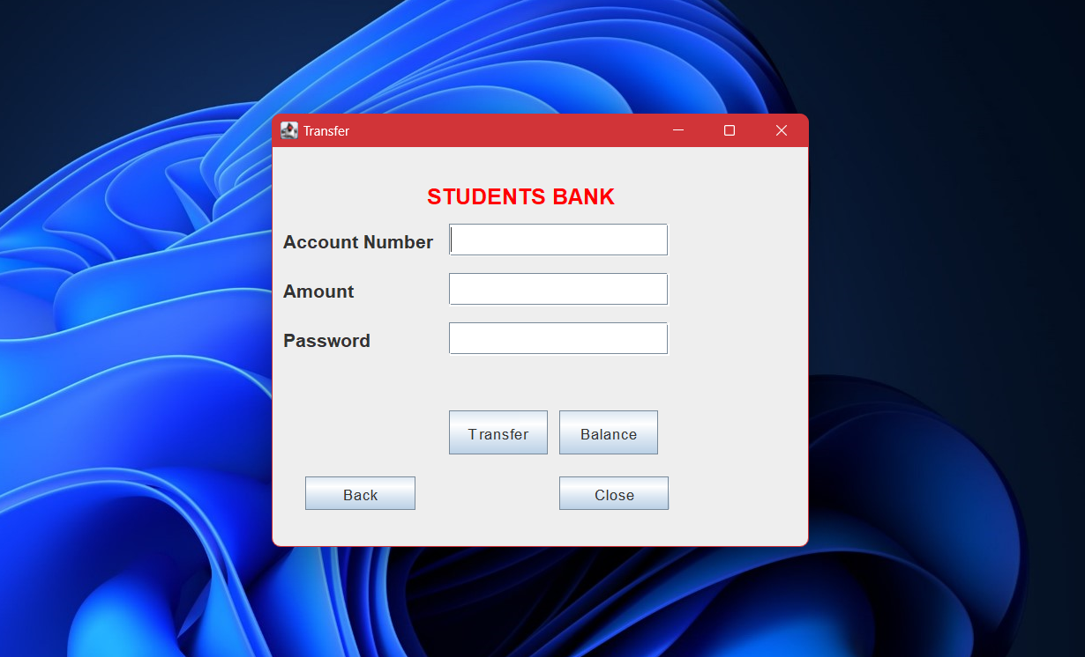

Fig.7 Money Transfer Page

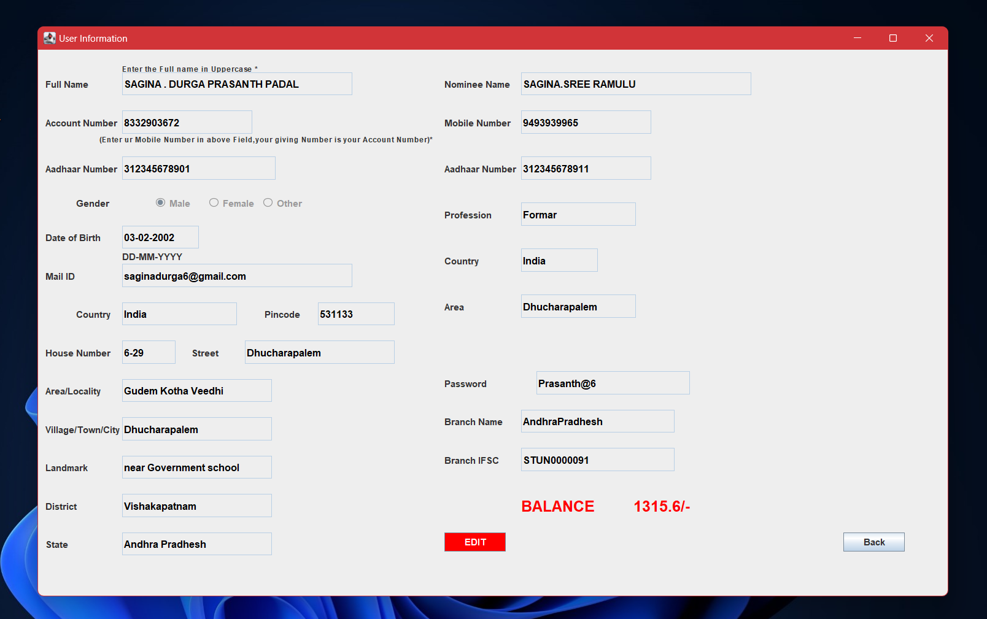

Fig.8 User Details Page

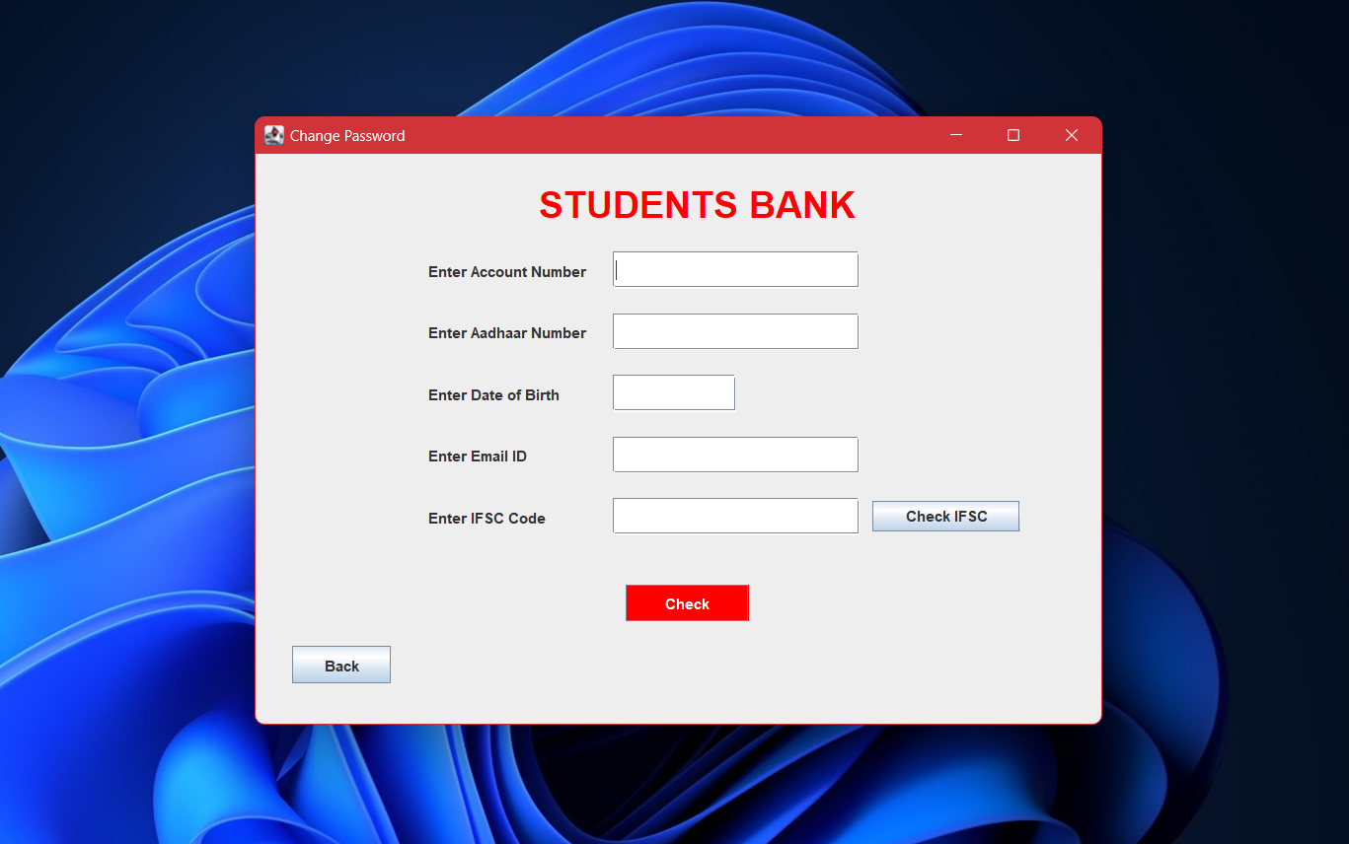

Fig.9 Password Changing Page

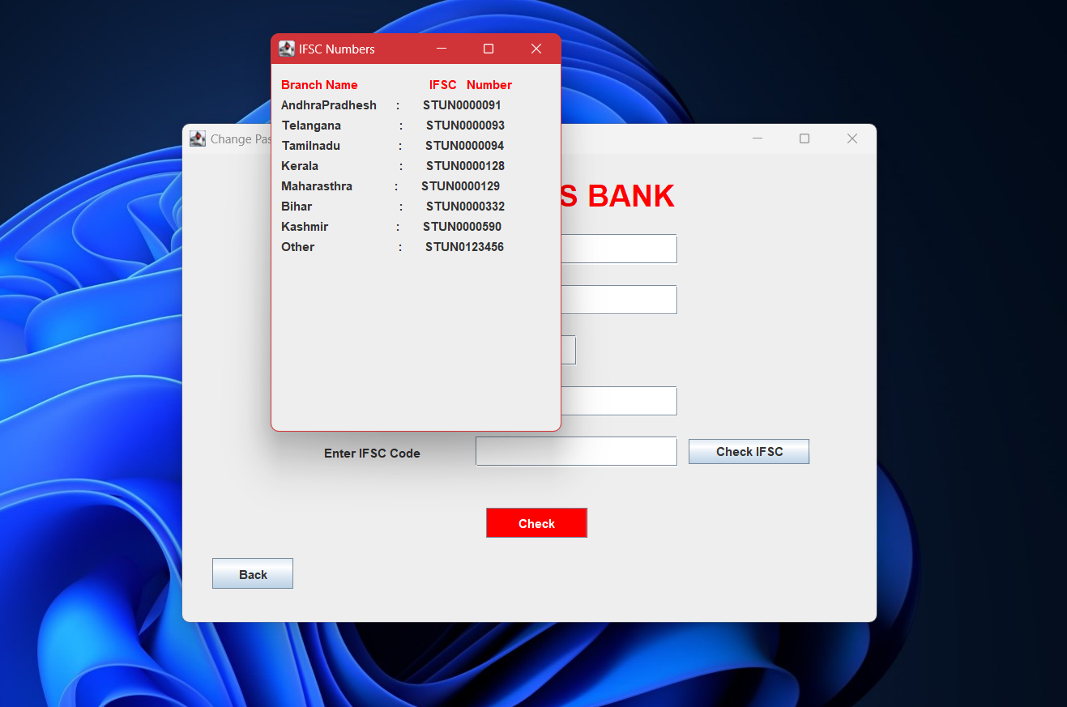

Fig.10 IFSC Checking Page

**DATABASE SCREENSHORTS**

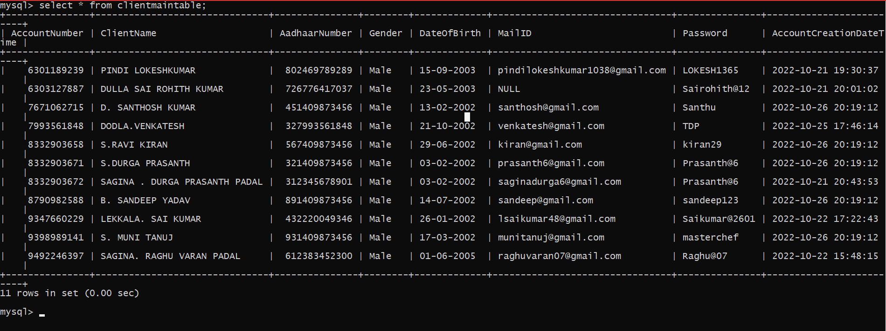

Fig.1 Client Main Table

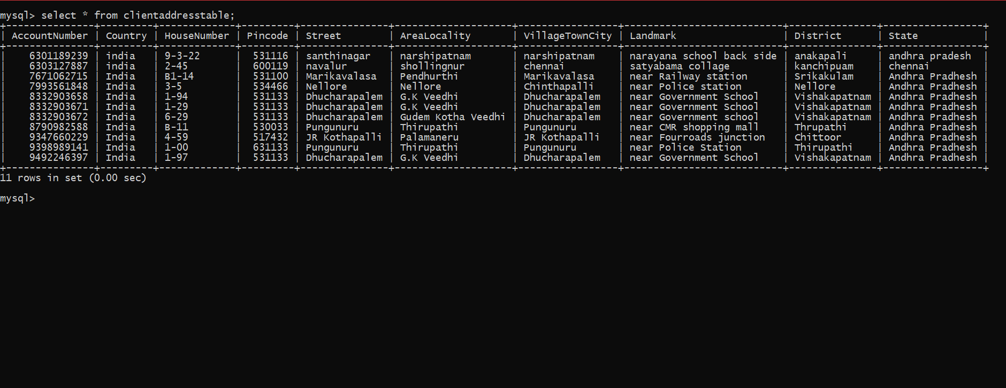

Fig.2 Client Address Table

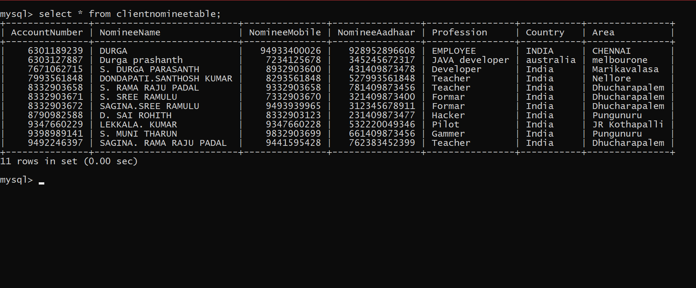

Fig.3 Client Nominee Table

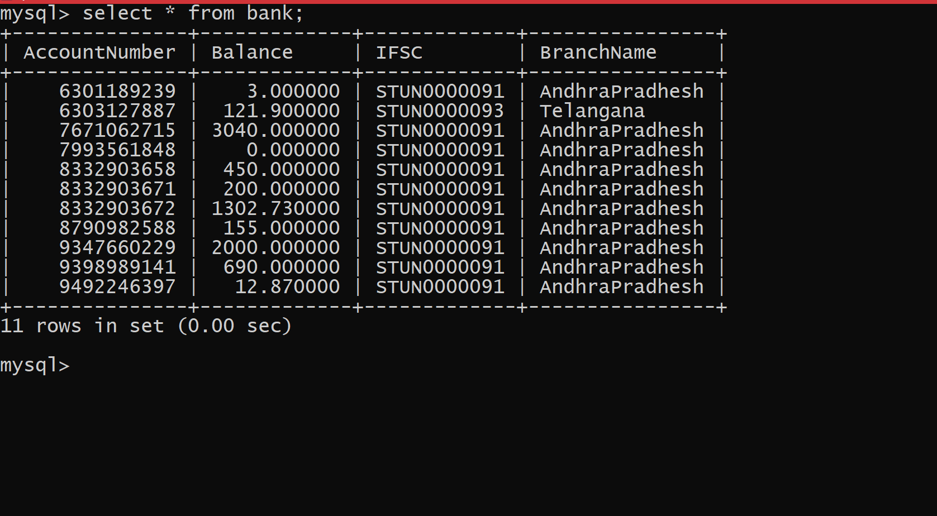

Fig.4 Bank Table